CineSketch
Backend Developer Manual

QAIG Private Limited

Cine Sketch Backend Contributing Guide

How to Contribute

Fork the repository

Create a new branch

Make your changes

Submit a pull request

Contributing Guide

Project Structure

The project is structured as follows:

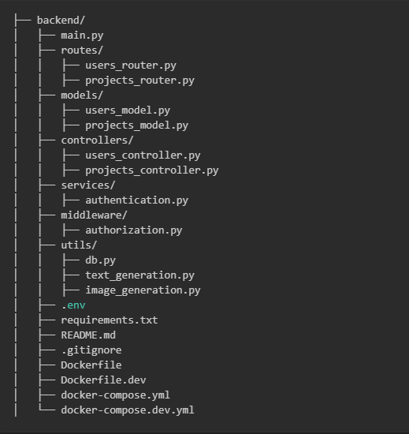

'main.py': The main entry point of the application.

'routers': Contains route definitions

'models': Pydantic models for request/response validation and database models.

'controllers': Handles API requests and responses.

'services': Contains the logic for authentication and database operations.

'middleware': Middleware for authentication and authorization.

'utils': Utility functions for database operations.

'.env': Environment variables.

'requirements.txt': List of dependencies.

'README.md': Project documentation.

'.gitignore': List of files to ignore in version control.

'Dockerfile': Dockerfile for the application.

Environment Variables

The .env file is used to store environment variables. It should not be committed to version control.

DB_HOST = 192.168.29.6

DB_PORT = 5432

DB_NAME = "PitchDeck"

DB_USER = "postgres"

DB_PASSWORD = Contact The Database Admin

Nomenclature

File Naming Convention

Use snake_case for file names. Example: main.py, users_router.py.

Use camelCase for class names. Example: UsersRouter, UsersController.

Variable Naming Convention

Use snake_case for variable names. Example: var_user_id, temp_var_user_name.

Use var_ for return variables. Example: var_user_id, var_user_name.

Use temp_var_ for temporary variables. Example: temp_var_user_id, temp_var_user_name.

Constant Naming Convention

Use SCREAMING_SNAKE_CASE for constants. Example: DB_HOST, DB_PORT.

Function Naming Convention

Use snake_case for function names. Example: fn_get_users, help_fn_create_user.

Use fn_ for function names. Example: fn_get_users, fn_create_user.

Use help_fn for helper functions. Example: help_fn_get_users, help_fn_create_user.

Note

Maintain a clean and well-documented codebase.

Use consistent naming conventions for variables, functions, and constants.

Maintain a change tracker in every file.

Write doc strings for functions and classes.

Use try-except blocks for error handling.

Write commits with descriptive messages.

